Functional Requirements (MVP)

Authentication and User Management

As an unauthenticated user, I can register a username and password.
As an unauthenticated user, I can login.

Employee(Unloader) Management
As an authenticated user, I can view a list of unloaders.
As an authenticated user, I can view unloader by name.
As an authenticated user, I can update unloader info.
As an authenticated user, I can update unloader status
As an ADMIN, I can add new unloaders.
As an ADMIN, I can remove unloaders.

Order Management
As an authenticated user, I can view all Orders.
As an authenticated user, I can view a list of orders by order number.
As an authenticated user, I can update order details.
As an authenticated user I can update Order Status.
As an ADMIN, I can create new Orders.
As and ADMIN, I can delete orders.

Customer Management
As an authenticated user, I can view all Customers
As an authenticated user, I can view customer information by customer name.
As an authenticated user, I can update customer information.
As an ADMIN, I can add new customers.
As an ADMIN, I can delete customers.

Shipper Management
As an authenticated user, I can view shipper information shipper name.
As an authenticated user, I can update shipper information.
As an ADMIN, I can add new shipper.
As an ADMIN, I can delete shipper.

Trailer Management
As an authenticated user, I can view all Trailers
As an authenticated users, I can view a trailer by trailer number.
As an authenticated users, I can update trailers info.
As an authenticated user, I can update trailers status
As an ADMIN, I can add new trailers.
As an ADMIN, I can remove trailers.

Project ERD
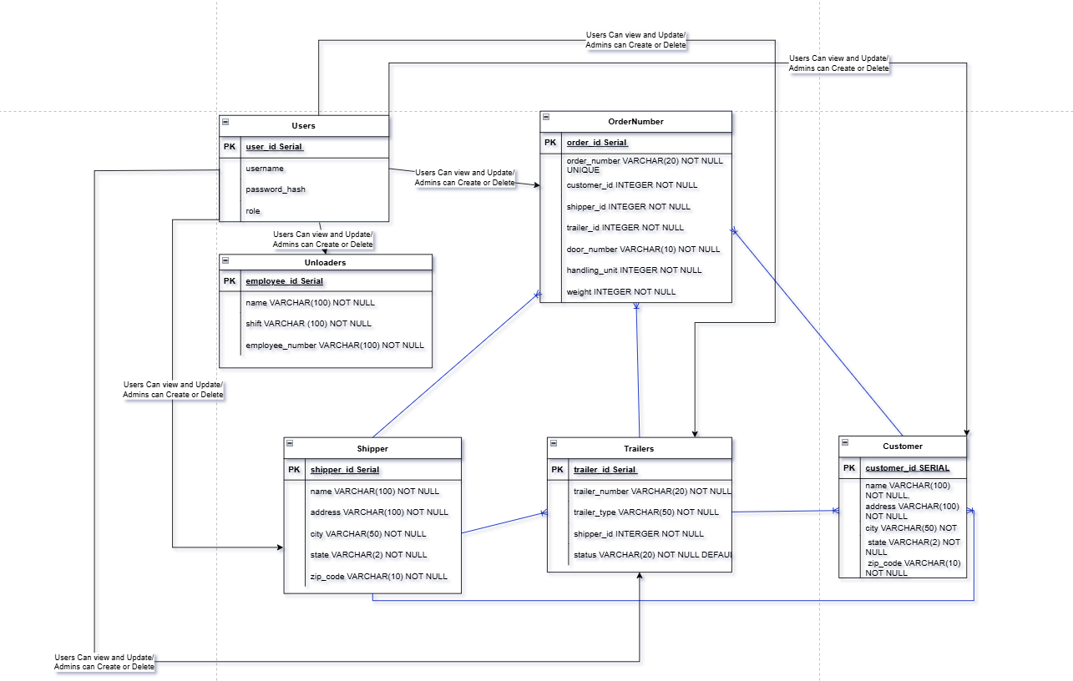

Endpoint | Method | Query Params | Description | Success | Error | Authentication
api/unloader | GET |  | Gets all Unloaders | 200 | 403,500 | User
api/unloader/name/{name} | GET |  | Get Unloaders by name | 200 | 403,404,500 | User
api/unloader | POST |  | Create Unloader | 201 | 403,500 | Admin
api/unloader/{id} | PUT |  | Update Unloader | 200 | 403,404,500 | User
api/unloader/{id} | DELETE |  | Delete Unloader | 204 | 403,404,500 | Admin
/api/customer | GET |  | Get All Customers | 200 | 403,500 | User
/api/customer/name/{name} | GET |  | Get Customer by Name | 200 | 403,404,500 | User
/api/customer | POST |  | Create Customer | 201 | 403,500 | Admin
/api/customer/{id} | PUT |  | Update Customer | 200 | 403,404,500 | User
/api/customer/{id} | DELETE |  | Delete Customer | 204 | 403,404,500 | Admin
/api/trailer | GET |  | Get All Trailers | 200 | 403,500 | User
/api/trailer/{trailerNumber} | GET |  | Get Trailer by Number | 200 | 403,404,500 | User
/api/trailer/{trailerNumber} | POST |  | Create New Trailer | 201 | 403,500 | Admin
/api/trailer/{trailerNumber} | PUT |  | Update Trailer | 200 | 403,404,500 | User
/api/trailer/{trailerNumber} | DELETE |  | Delete Trailer | 204 | 403,404,500 | Admin
/api/shipper | GET |  | Get All Shippers | 200 | 403,500 | User
/api/shipper/name/{shipperName} | GET |  | Get Shippers by Name | 200 | 403,404,500 | User
/api/shipper/name/{shipperName} | POST |  | Create Shipper | 201 | 403,500 | Admin
/api/shipper/{id} | PUT |  | Update Shipper | 200 | 403,404,500 | User
/api/shipper/{id} | DELETE |  | Delete Shipper | 204 | 403,404,500 | Admin
/api/orders | GET |  | Get All Orders | 200 | 403,500 | User
/api/orders/trailer/{trailerNumber} | GET |  | Get All Orders by Trailer Number | 200 | 403,404,500 | User
/api/orders/number/{orderNumber} | GET |  | Get order by Order Number | 200 | 403,404,500 | User
/api/orders/customer/{customerName} | GET |  | Get orders by Customer Name | 200 | 403,404,500 | User
/api/orders/shipper/{shipperName} | GET |  | Get Orders by Shipper Name | 200 | 403,404,500 | User
/api/orders/status{status} | GET |  | Get Orders by Status | 200 | 403,404,500 | User
/api/orders | POST |  | Create New Order | 201 | 403,500 | Admin
/api/orders/orderNumber/{orderNumber} | PUT |  | Update Order by Order number | 200 | 403,404500 | User
/api/orders/orderNumber/{orderNumber} | DELETE |  | Delete Order by Order Number | 204 | 403,404500 | Admin

